WWI
- Causes
  - Nationalism
  - Imperialism
  - Militarism
  - Alliance System
- Assassination
  - Balkan Peninsula
    - Powder keg
  - Franz Ferdinand: Heir to the thrown
    - Murdered
      - Black hand
  - Austria-Hungary declared war
    - Alliance system
      - Germany declares on Russia
      - France on Germany
      - Britain on Germany
      - Allies: France, Russia, Britain, Serbia
      - Central Powers: Austria-Hungary, Ottomans, Bulgaria, Germany
- Fighting
  - Schlieffen Plan
    - Hold war against Russia
    - Take over France
    - Then go back to Russia
  - Trench Warfare
    - No man’s land
- Americas Role
  - Stay out
    - No impact on us
    - Not a threat to America
    - Didn’t want sons to die
  - Involved
    - Heritage
      - Many were fresh to the U.S. still had relatives over there
      - Followed war very closely
      - German, Ireland
      - Close to Britain common governments
    - Economic
      - Sold goods to central powers
      - Trade with France and Britain double that of trade with Germany
- War hits home
  - British blockade
    - U.S. wouldn’t challenge
    - Germany struggling to get supplies
      - Famine
  - German U boats
    - Lusitania
- 1916 Presidential Election
  - Dems nominate Wilson
    - Ran on man who keep you out of the war
  - Republicans Justice Charles Hughes
  - Race was close
    - Wilson Prevails
- Declaration of war
  - Wilson
    - League for peace
  - Zimmerman Note
    - Alliance proposal from Germany to Mexico
  - More ships destroyed
    - American lives being lost
  - Russia turns to a representative government
    - War would now be democracies against brutal monarchies of the world
  - Declare war in April of 1917
- Mobilization
  - 200k soldiers in service
    - Little leadership
    - Lack experience
  - Selective Service Act
    - Draft : all men 18 years old must register
    - 24 million men register
    - 3 million selected to join the military
  - Expand the fleet
    - Exempted shipyard builders from draft
    - Campaign to work on ships
    - Fabricated ships
    - Took over civilian ships
  - Convoy system
- Fighting
  - U.S. brings sense of enthusiasm and freshness
  - American Expeditionary Force (AEF)
    - General John J. Pershing
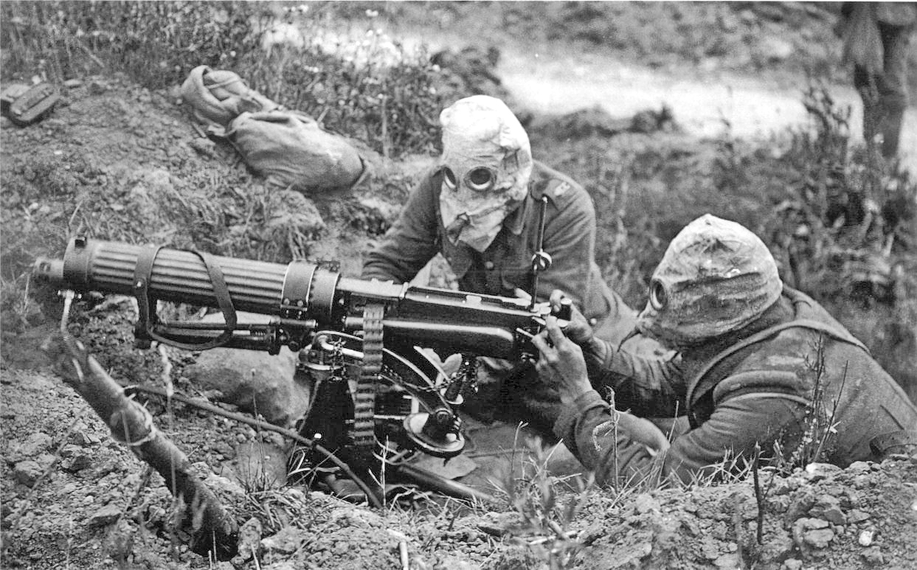
    - Doughboys
- Technology advances
  - Machine gun
  - Tank
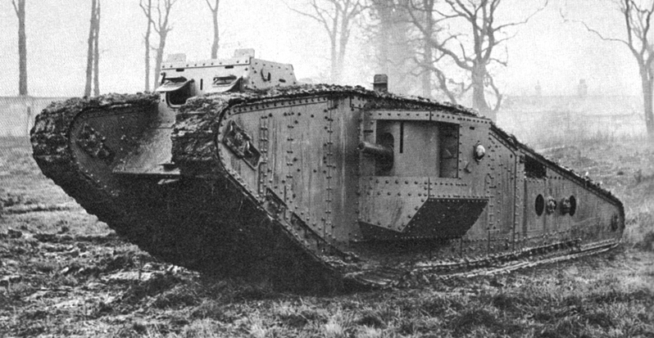
  - Airplane
  - Poisonous Gas
- Hazards of war
  - Trench Warfare
    - Lice, rats, polluted water, dysentery
    - Lack of sleep
    - Shell shock
    - Trench foot
- Tide turns
  - Russia pulls out of the war 1917
  - Germany moves forces to the western front
  - 50 miles from Paris
    - U.S. and allies stop them
    - Go on the offensive
- War Ends
  - Nov 3, 1918 Austria-Hungary surrenders
  - German Mutiny on the seas
    - Kaiser Wilhelm give up thrown
  - 11th hour 11th day, 11th month 1918 war ends sign the armistice
  - Costs
    - 22 million died
      - Half civilians
    - 20 million wounded
    - 10 million now refuges
    - 338 billion dollars
    - U.S.
      - 48k soldiers died in battle
      - 63k died of disease
      - 200k wounded
- War At home
  - Economy focused on war
  - Government and business collaborated on joint effort
  - War Industry board
    - Mass production techniques
    - Production increased by 20%
    - Gasoline, oil rationed
    - Day light savings time
  - Food Administration
    - Herbert Hoover Head
    - Clear plate
      - Meatless, sweetless, wheatless, porkless
  - Finance
    - U.S. spent 35 billion
      - Raised taxes
        - Progressive tax
      - Sold bonds
  - Propaganda
    - Committee on Public Information
    - Popular artists
      - Paintings
  - Anti-Immigrant hysteria
    - German, Austria Hungary
    - Change names of goods to not reflect German ancestry
      - Hamburger
        - Salisbury steak
  - Espionage and sedition acts
    - 10k fine
    - 20 years in jail
    - Interfere with the war effort
  - Great Migration
    - Black Americans move North
      - Escape Jim crow south
      - More job opportunities in north
  - Women and war effort
    - Worked jobs for men
      - Railroads, mineworkers, red cross
  - Influenza b Hits world
    - 30 million people die worldwide
    - 500k in the U.S.
- Plan for peace
  - Wilson introduced 14 pt plans
    - Stop another war
      - No secret treaties
      - Freedom of seas for all
      - No more tariffs
      - Reduce weapon numbers
      - Colonial decisions should be impartial
    - Boundary changez
      - Germany leaves Russia
      - Belgium independent
      - Self-determination for Austria-Hungary, Balkans
    - Pt 14 was League of Nations
      - Forum for nations to discuss and settle grievances without having to fight a war
    - Wilsons plan was naïve
      - Allies had too much anger
        - France fought 2 wars with Germany
        - Britain Prime Minister ran on campaign of making Germany pay
    - Peace Conference
      - No central powers were there
      - Wilson conceded most of his plan in order for league of nations to happen
- Treaty of Versailles
  - Terms
    - 9 new nations created
      - Poland, Czechoslovakia, territories to Britain and France
        - Israel
    - Germany could not maintain an army
    - Germany must pay reparations
            - 33 billion
  - Flaws
    - War guilt clause
    - Germany couldn’t pay
      - Lost territories country was destroyed
    - Russia not part of the plan
      - Lost more territory than Germany
      - Vowed to take it back
    - Lacked self-determination for territories
- Opposition
  - Congress did not like the terms
    - Didn’t like the reparations
    - More imperialism
    - No self-determination
  - Didn’t like league of nations
    - Threatened U.S. idea of isolationism
    - Congress still wanted power to declare war
  - Never joined league of nations
- Legacy
  - Stronger military and government
  - Social change
  - Anti-immigrant sentiment

