Latitude and Longitude Worksheet
Use the map to answer the following questions about latitude and longitude.
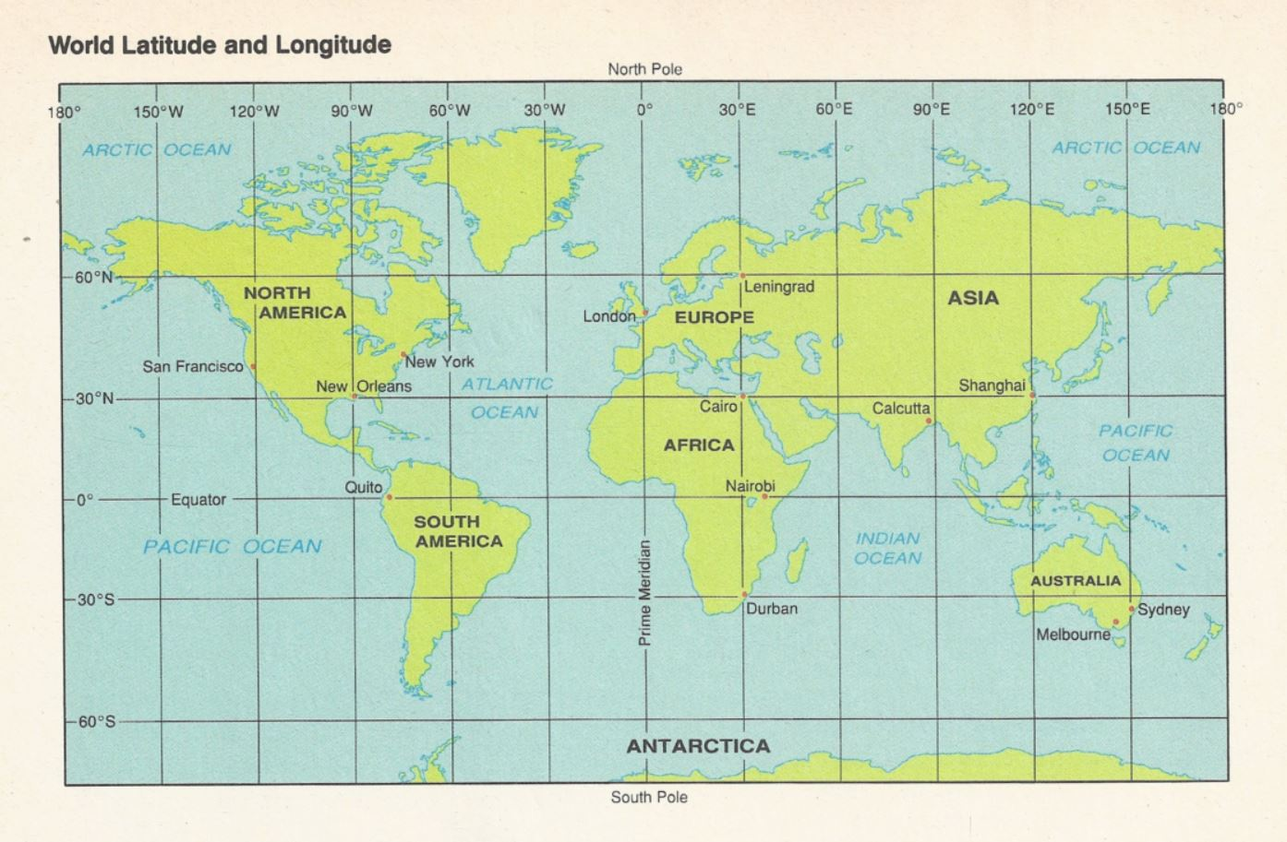
- What ocean does the Prime Meridian cross the equator?
- Atlantic b. Pacific c. Indian d. Artic

- What two continents does the equator cross?
- North America and South America c. Africa and Europe
- Africa and South America d. Australia

- Which one of these continents lies completely in the Southern Hemisphere?
- North America c. South America
- Asia d. Australia

- What ocean lies completely in the Eastern Hemisphere?
- Atlantic b. Indian c. Pacific d. Artic

- What continent lies completely north of the equator and east of the Prime Meridian?
a. Europe b. Asia c. Africa d. North America

- On what continent would you find the place with a latitude of 20° N and a longitude of 0°?
a. Europe b. Asia c. Africa d. South America

- On what continent would you find each of the following locations?
  - 60°N, 100°W __________________________________
  - 60°N, 100°E __________________________________
  - 20°S, 60°W __________________________________
  - 20°N, 20°E __________________________________
  - 20°S, 140°E __________________________________

- Identify the city and lies closest to each pair of coordinates.
  - 30°N, 90°W __________________________________
  - 30°N, 30°E __________________________________
  - 60°N, 30°E __________________________________

- Give the coordinates for each city.
  - Shanghai, China ________________________________
  - Durban, South Africa _____________________________

- Identify the city with each pair of coordinates.
  - 0°, 78°W ____________________________________
  - 51°N, 0° ____________________________________
  - 38°S, 145°E ____________________________________

- Estimate the coordinates for each city to the nearest degree.
  - Calcutta, India __________________________________
  - Nairobi, Kenya __________________________________
  - New York, New York _____________________________

